Chang’an University 2023－2024 The 2nd semester （ A ）
Course | Hydraulic and Pneumatic Transmission |  |  | Date |  | / / |  | 18 questions
Name |  | School |  |  | Class |  | ID
I Fill in the blanks. (20 points, 1 point for each blank)
- The hydraulic system can be divided into five logical segments, they are , , , and working oil.
- Please write out three hydraulic auxiliary components: , , .
- The three basic motion equations to describe the dynamics laws in flowing fluid are , , .
- According to Reynolds test, the main states of fluid flow are and in a pipe.
- There are three basic types for speed control circuits. They are , , . (Hints: Speed regulating can be done by two methods, i.e., changing input flow rate or displacement)
- In a pipe system, there are two energy loss types, and . (Hints: The first one is the energy losses due to viscosity in equal diameter pipe. The second one is the energy losses when fluid flows through pipe entrance or exit, sudden variety across-sections etc.)
- The common pressure operated valves include , , and pressure relay.
II Short answer question items. (20 points, 5 points for each)
- Please explain the phenomenon of surrounded oil and the method for solving it.

- What is the delivery of hydraulic motor? Please explain the volumetric efficiency and mechanical efficiency of hydraulic motor?

- The basic conditions that make up a hydraulic pump.

- Please write out the differences between pilot operated relief valves and pilot operated pressure reducing valves.

第 1 页(共 4 页)
III Calculations. (25 points)
1. In the horizontal pipe shown in the diagram below, an ideal fluid flows to the right, with its outlet open to the atmosphere. v1=3m/s, d1=80mm, d2=50mm. Assume that α is 1 and liquid density is 900kg/m3. Ignore all energy losses. Please calculate the parameters below. (10 points)
(1) Flow rate q through the cross-section 1-1. (3 points)
(2) The flow velocity v2 at the outlet. (3 points)
(3) The pressure difference Δp between the cross-section 1-1 and 2-2. (4 points)
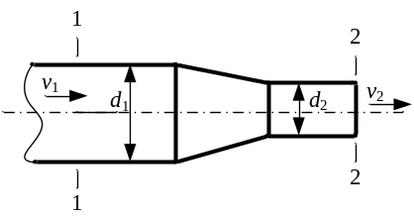

2. Consider the three different structural types of hydraulic cylinders shown in the diagram, with piston diameters D and rod diameters d. Given a flow rate q and pressure p into the cylinders. Please write the mathematical expression of the thrust, the velocity of the cylinder, and determine the movement direction for each type of cylinder. (10 points)
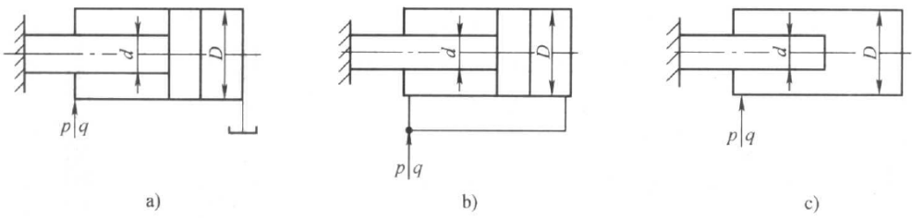

3. In the circuit shown in the diagram, the area of the cylinder chamber without the rod is 50 cm², and the load F_{L} is 10,000 N. The set pressures for each valve are indicated in the diagram. Calculate and determine: (5 points)
(1) The pressures at points A and B when the piston is in motion; (3 points)
(2) The pressures at points A and B when the piston stops at the end of its stroke. (2 points)
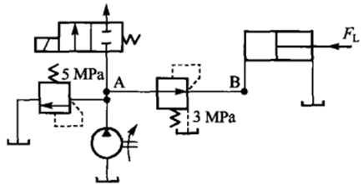

第 2 页(共 4 页)

IV Diagramming question. (15 points)
Please write the name of basic hydraulic circuits (6 points) and hydraulic components (9 points).

(1) | (2)
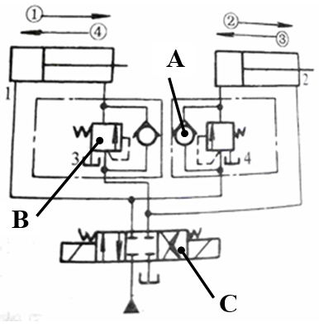 | 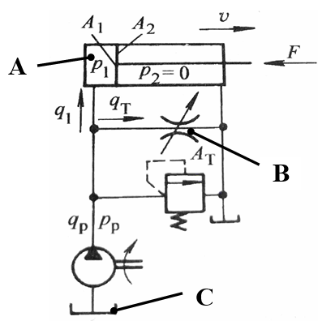

Hydraulic basic circuit |  |  | Hydraulic basic circuit
Component A |  |  | Component A
Component B |  |  | Component B
Component C |  |  | Component C

(3)
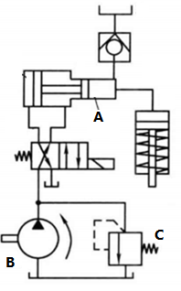
Hydraulic basic circuit
Component A
Component B
Component C

第 3 页(共 4 页)
V Analysis. (20 Points)
In the hydraulic system shown in the diagram, Pump 1 is a pump with a small flow rate and Pump 2 is a large-flow-rate pump. Actuator 9 finishes autocratically in a cycle motion of “fast extends → slow extends → quick retract” respectively. Analyze the diagram and answer the following questions:
(1) How does the system achieve the “fast extends” motion, what is the path of oil flow during this motion, and what is the name of the basic circuits used? (7 points)
(2) How does the system achieve the “slow extends” motion, what is the path of oil flow during this motion, and what is the name of the basic circuit used? (7 points)
(3) How does the system achieve the “quick retract” motion, and what is the path of oil flow during this motion? (6 points)
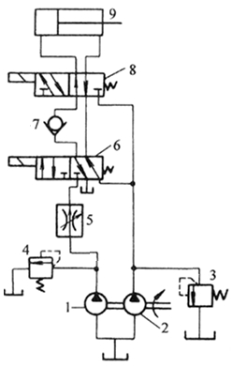

第 4 页(共 4 页)

